# Client

My client is an Asian restaurant named Dragon Sky. It mainly makes Asian-inspired dishes. Their business is booming, and they often have to queue to eat. In order to allow more customers to eat delicious and delicious meals, the restaurant decided to expand its online business. Invite us to customize a food ordering system for them, allowing customers to order in the store and take out home delivery service.

# Style

As an Asian restaurant, the restaurant hopes to retain the Asian flavor in the color scheme. In addition, the style should be simple, with lots of eye-catching pictures, so that customers can know the purpose of the page at a glance.

There are two main pages, one is the introduction page, where there will be a restaurant introduction and an order menu introduction, and on this page, customers can directly purchase and order meals. Another page is the order page, which will be a form where the customer's entry will be validated.

There are some examples:

Culinaria: https://www.culinariafoodandwine.com/

The Noodle Box: <https://thenoodlebox.net/>

The Pizza Express: https://www.pizzaexpress.com/

# Platform

The website will target traditional monitor resolutions of 1024X768 and greater.

The website also fits mobile device.

# Semantic Design Guide

Font:

Whole page: Verdana, Geneva, Tahoma, sans-serif;

Color:

* Pink White: #fbf2e3
* Light. Grey: #e4dfd7›
* Dark grey: #e4dfd7
* Light orange: #ffa60f
* Dark orange: #ff9900
* Light brown: #806332
* Dark brown: #815f25

|  |  |  |  |  |  |  |
| --- | --- | --- | --- | --- | --- | --- |
|  |  |  |  |  |  |  |
| #fbf2e3 | #e4dfd7 | #e4dfd7 | #ff9900 | #ffa60f | #815f25 | #806332 |

## Landing page

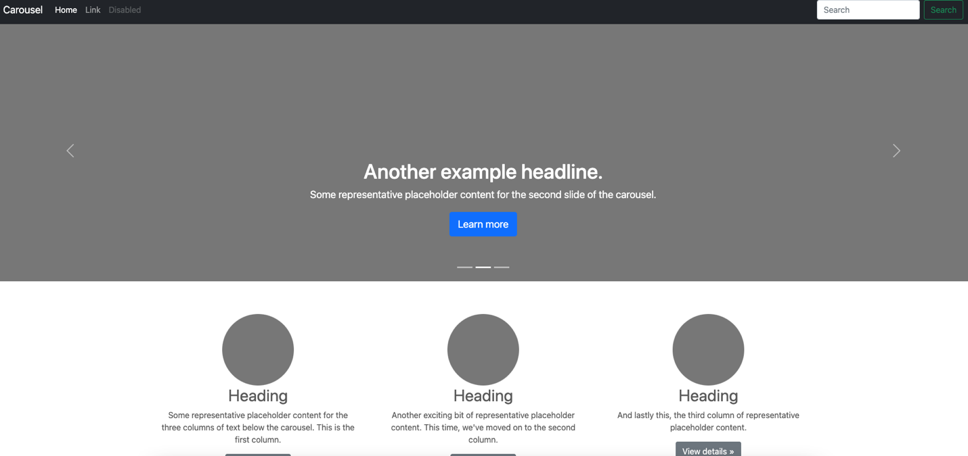

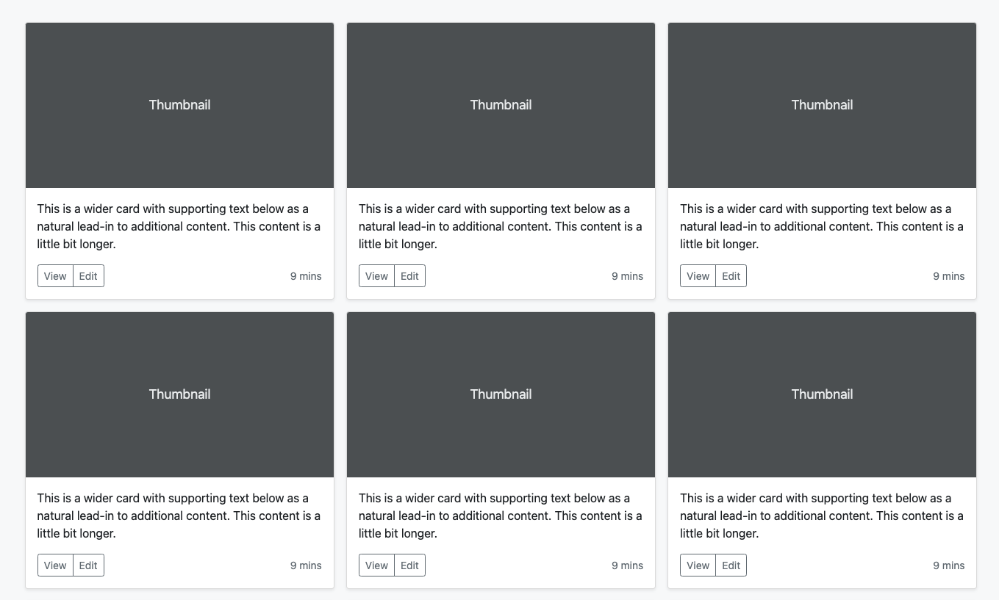

We will use bootstrap Carousel and Album templates for building landing page.

<https://getbootstrap.com/docs/5.1/examples/carousel/>

<https://getbootstrap.com/docs/5.1/examples/album/>

<html>

* All pages own a common setting.
* All background color is Light Grey: #e4dfd7;
* All text’s color is a combination of Light brown: #806332 and Dark orange: #ff9900
* If any element has a hover, the color will toggle between Dark brown: #815f25 and Dark orange: #ff9900

<body>

* Body contains three parts, they are nav bar, main session and footer
* All body font default setting is ' Verdana, font-size: 25px

<header>

* The header element is used for the top matter of a document which including the log and main navigation.
* The header will stick on top while you scroll down
* The font of logo is Caveat, font-weight is 400, color is #5c4312, size is 2em

<nav>

* The nav element is used to identify navigation.
* It presents three blocks of information. They are logo, navbar itself and a cart icon shows how many items is selected.
* The nav bar use bootstrap structure.
* The font of navigation is Geneva, font-weight is 200, color is light, size is 18px.
* The nav bar use Pink White: #fbf2e3 as background and have a 2px slight border beneath it
* Logo stick on the left, font-weight is bolder. it’s font color is Dark orange: #ff9900.
* Logo image is 33px*33px square
* Navbar has the function of dropdown
* There ia a shopping cart icon stick on the right, and around it presents a number indicates the quantity you have choose. It’s dynamic.

<main>:

* Main part can be divided into four sessions, they are Carousel page, Meal section, about session and location part.
* All of four sessions use bootstrap template.

#myCarousel

* Carousel page enjoys a height of 40 rem
* The images used in carousel have 80% of opacity so it will not be much bright which look much better and the caption on it can be seen clearly.
* The caption on the image has 3rem font size and 2 px letter spacing. It’s color is #fff and has a white border in every four directions
* The button in it will bring you to different parts in this page.

#location

* The meal session use bootstrap Album structure
* The meal session present 6 meals wrapping in six cards. Each card has a structure of an image on top, beneath it presents price, beside it has two buttons, using those buttons user can add or subtract amounts needed. One thing should be noticed is that the amount has a limitation, it should greater than zero and no more than 5
* Color uses in meal session is Dark brown and dark Orange. Font is 25px with font-weight bold.
* Images also has 80% opacity, so that the image will not be so striking to eyes

#about

* Color uses in about session is Dark brown and dark Orange. Font is 25px with font-weight bold.
* This part’s structure is am image on the left and text on the right
* Images use in this session is 500*300, has 80% opacity
* Text align is right

#location

* This part’s structure is three columns wrapped in flex box, each part has a rounded images on the top and description text beneath it.
* Images use in this session is 300*300 rounded, has 80% opacity
* Color uses in location session is Dark brown and dark Orange. Font is 20px with font-weight bold.
* It has 5rem margin on the bottom.

<footer>

* The footer element includes nav function, and group member Information.
* Footer will stick in the bottom whatever the page length
* Color uses in location session is Dark brown and dark Orange. Font is 20px.

Layout location for elements:

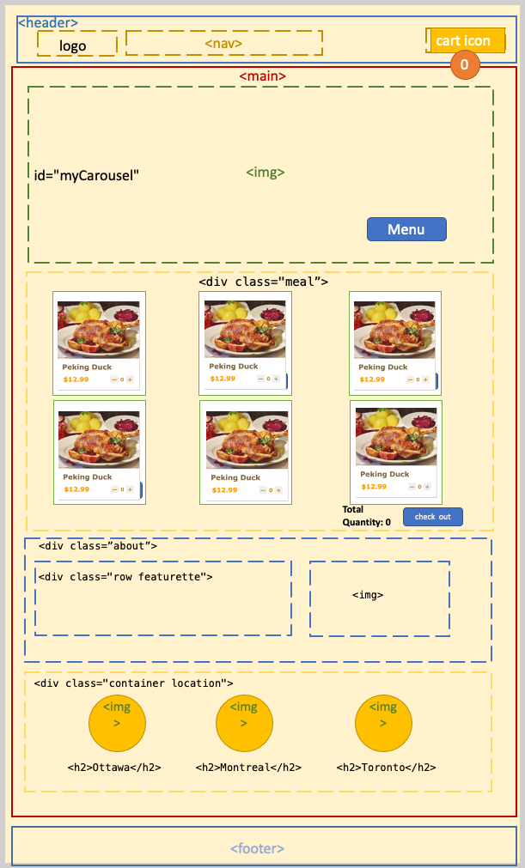

## Form page

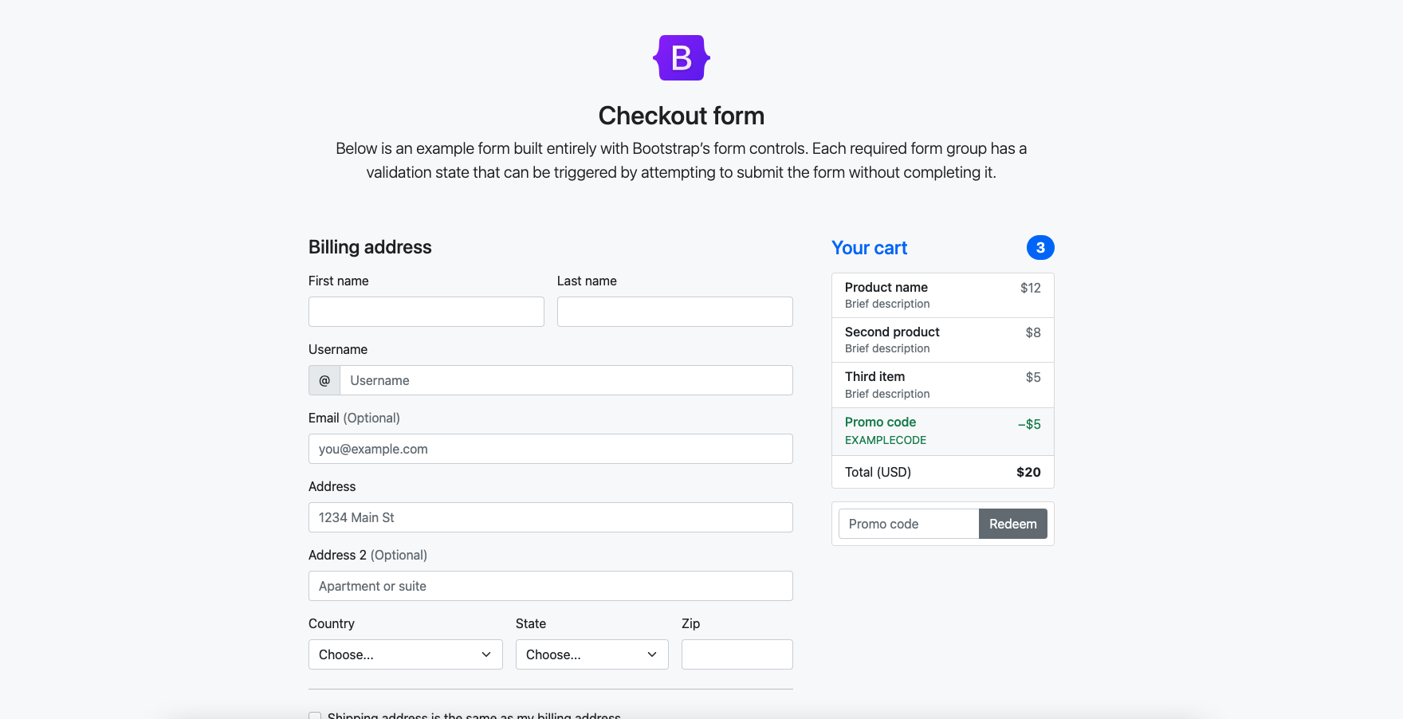

We will use bootstrap Checkout templates for building landing page.

<https://getbootstrap.com/docs/5.1/examples/checkout/>

<html>,<body>,<header>,<footer> and <nav> of header are same with landing page.

It uses a form in the left to collect customer information, and on the right is a simplified shopping cart.

<form>

* Color uses in location session is Dark brown and dark Orange. Font is 20px.

Layout location for elements:

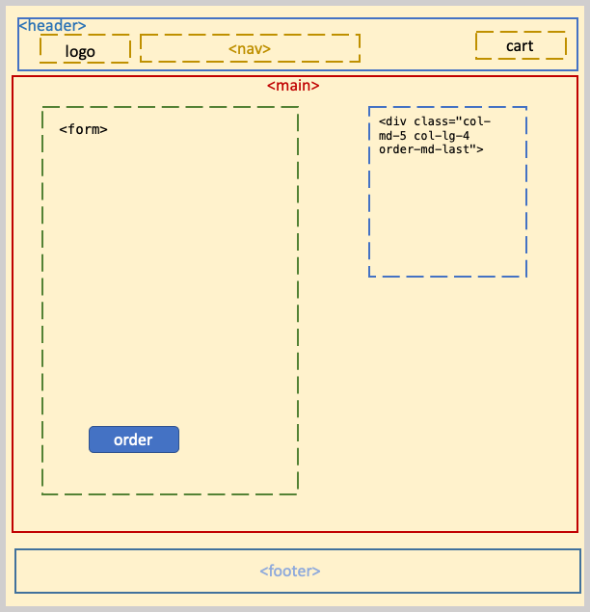

# interface functionality guide

1. Index page has scroll reveal animation, it will use <https://unpkg.com/scrollreveal> library , the scripts in index.js file.
2. Index page menu part, there are “-“ and “+” buttons in every dish card.

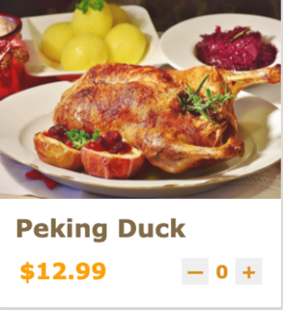

The script of buttons in index.js, if users click “+” button of one dish, the dish will be added in cart, and the number of cart item will update. if users click “-” button of one dish, the dish will be deleted in cart, and the number of cart item will update. When users click these buttons, the dishes data will store in cookies and paper to pass to book.html. When users finish order, they can click the cart icon in nav bar and “check out” button in menu, it will switch to book page.

1. The book.js file will receive the dishes data added in cart, and it will construct these data in a new object, so that it can display them in the cart list of book page. In this page, user also can edit the number of every dish and remove which one they don’t want to order. These button functions are in book.js, through clicking invoke these functions.
2. The form.js file will validate the form of book page. Users will input their personal information and payment way.

# Website Map